Midwest Principals Center Adobe Connect:
Participant Preparation

Please use the following instructions to test your equipment and to connect to the Adobe Connect session.

Prior to the day of the session:
Get a microphone and speakers (if not built-in) to hook to the computer that is going to be used for the session. A headset with microphone works best in an individual setting. A web camera is optional.

On the day of the session:
- Please log on 5-10 minutes prior to the start time to double check your system. Click on the link below:
http://dupage.adobeconnect.com/mpc/
This link will be open approximately 30 minutes prior to the start time.
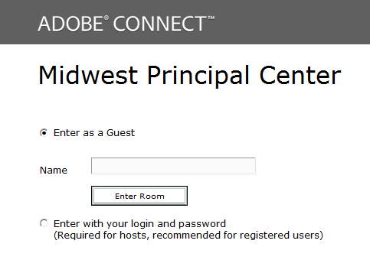

- Choose the “Enter as a Guest” option

- Type your name

- Click on “Enter Room”

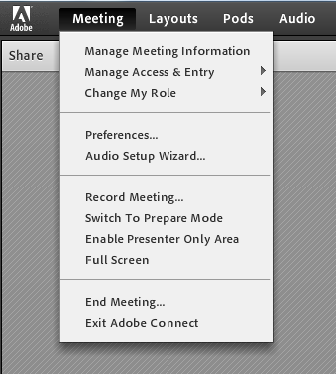

- Test your audio using:
MeetingAudio Setup Wizard

Important: Test your speakers (to hear the presenter and the other sites) and microphone (to talk to the presenter and the other sites.)

- You are now ready to participate in the session.

